**COPYRIGHT AGREEMENT FORM**

Paper ID : **IRJMETS60500230430** Date: May 26, 2024

Author(s) name: Md Rashed , Shoaib Ahmad , Md Shakil Hossain

Paper Title "**Optimizing Waste Management with IoT: Boosting Efficiency and Promoting Sustainability**" Do hereby authorize you to publish the above said article/research paper in, International Research Journal of Modernization in Engineering Technology and Science.

Author(s) Postal Address: Post Office: Hasangonj-8340, Upazila: Charfasson, District: Bhola

Email: [rashedulislam200613@gmail.com](mailto:rashedulislam200613@gmail.com) Mobile: +8801780340222

**COPYRIGHT STATEMENT**

1. By submitting your article, you grant us the exclusive right to both reproduce and/or distribute your article throughout the world in electronic, printed or any other medium, and to authorize others
2. By submitting your article for our publication, you promise that the article is your original work, has not previously been published, and is not currently under consideration by another publication.
3. If the article contains material that is someone else’s copyright, you promise that you have obtained the unrestricted permission of the copyright owner to use the material and that the material is clearly identified and acknowledged in the text.
4. 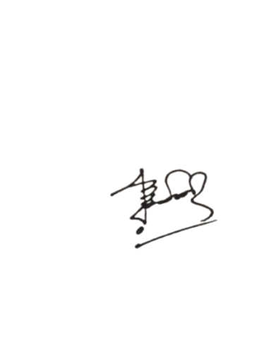By submission of a manuscript the corresponding author confirms that all co-authors have seen and approved the validity of the contents and approve the manuscript’s submission
5. On behalf of all co-authors, the corresponding author shall take complete responsibility for the submission and its correspondence and the Publisher cannot be held responsible for any incomplete or incorrect manuscript submitted by the corresponding author(s).

Author's signature:

Author's Name : Md Rashed

Institute Name : Pabna University of science and Technology

Date and Place: May 26, 2024, Pabna Sadar , Pabna

Please send the completed form to- [editor@irjmets.com](mailto:editor@irjmets.com), irjmets@gmail.com